Q:- Local Procedure to calculate the sum of two number.
DECLARE
--Local procedure to calculate the sum of two numbers
PROCEDURE calculate_sum (num1 IN NUMBER, num2 IN NUMBER) IS
BEGIN
DBMS_OUTPUT.PUT_LINE('Sum of ' || num1 || 'and' || num2 || 'is:' || (num1+num2));
END calculate_sum;
BEGIN
--Calling the local procedure
calculate_sum(10,20); -- Sum of 10 and 20
calculate_sum(50,30); --Sum of 50 and 30
END;
/
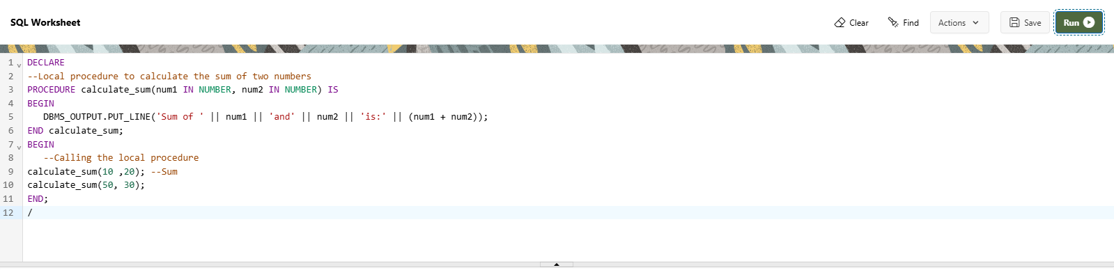
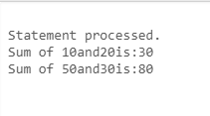

Q:- stored procedure to calculate the sum

CREATE OR REPLACE PROCEDURE calculate_sum(
num1 IN NUMBER,
num2 IN NUMBER,
result OUT NUMBER
) IS
BEGIN
result := num1 + num2;
END calculate_sum;

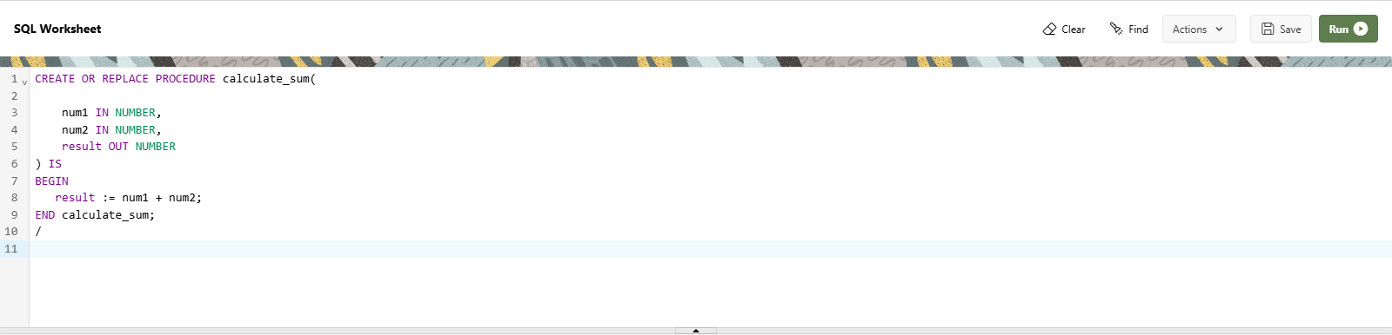

DECLARE
sum_result NUMBER;
BEGIN
calculate_sum(10, 20, sum_result);

DBMS_OUTPUT.PUT_LINE('The sum is: ' || sum_result);
END;



